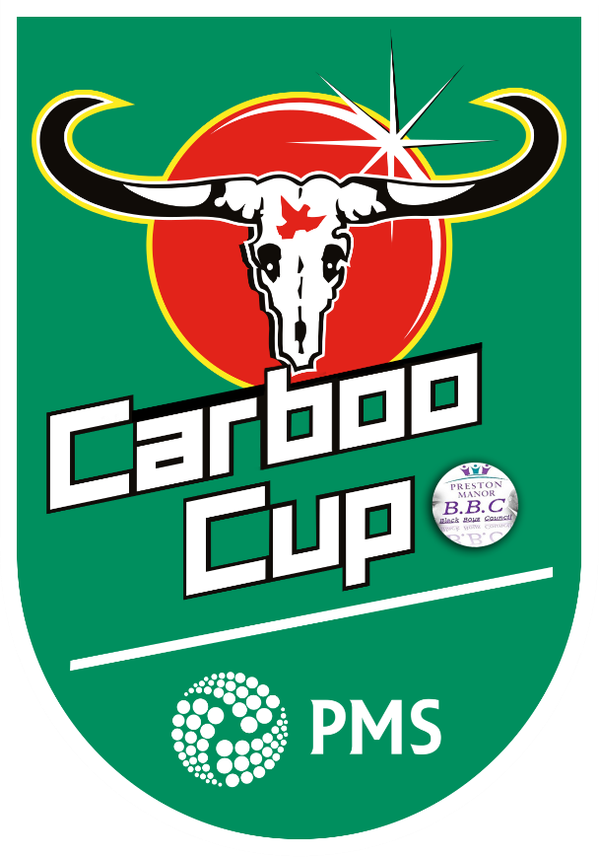
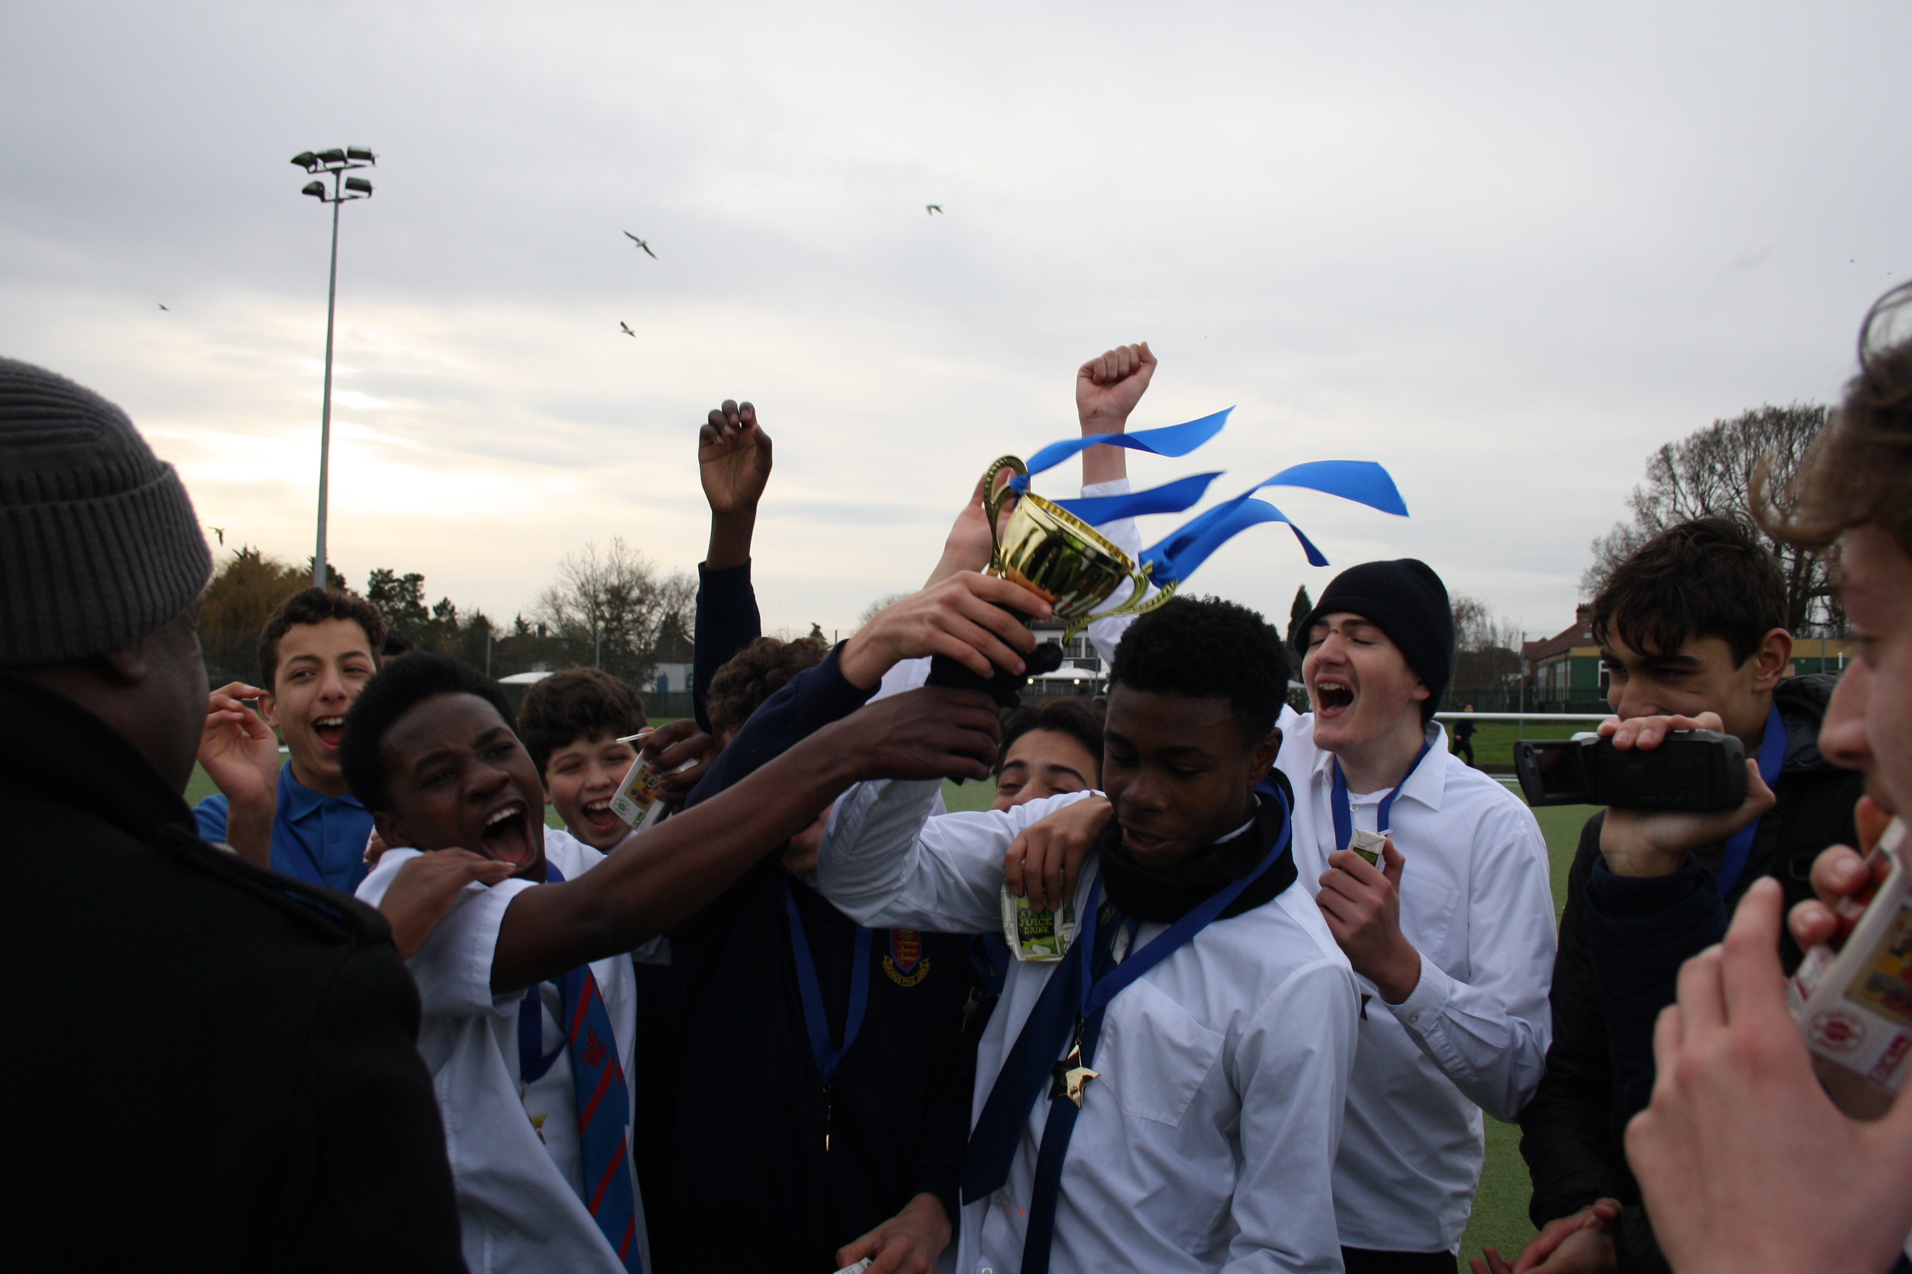

Carboo Cup Winners - West Ham
The Carboo Cup is a tournament was run by Mr. Carboo in the Mentoring department. The aim was to give students a focus for lunchtimes, get the year groups to mix and interact positively with each other, and develop respect, discipline, and leadership skills. The Carboo Cup has been a great tournament. It has been very exciting and the students have really enjoyed the fact the tournament consisted of four London Premiership teams; Spurs, Arsenal West Ham and Chelsea.
Overview
- 4 staff referees
- Yr11 students as managers of teams
- Over 80 students involved from Yr7 – Yr11
- Winning team rewarded with the Carboo Cup trophy displayed with their team photo in the hall, Pizza Party and FIFA 20 Tournament
- Promotes social cohesion across the year groups
- Promoting positive staff/student relationships
- Two matches played simultaneously on Wed and Fridays
- Large numbers of students would gather to watch the matches each day
- Gave students a positive focus and topic of discussion
- Students reported to of felt happier, more relaxed and had something to look forward to at school.

Student quotes:
Student 1: The Carboo cup was a brilliant tournament. All years played together. It made everyone connect. It was good clean completion and we got to know the other year groups.
Student 2: The Carboo cup was organised very well, and we played two matches played at the same time every Wednesday and Friday. It was really exciting, it brought students together and developed us. But if you got a serious sanction in school you would be banned from the match!
Student 3: The Carboo Cup helped the older years build relationships with the younger students which we don’t usually speak to. It built respect. We learned to play fairly, take a loss and Mr. Carboo made sure we always shook hands after matches.

The Carboo Cup was won by West Ham with the score being 1-0. 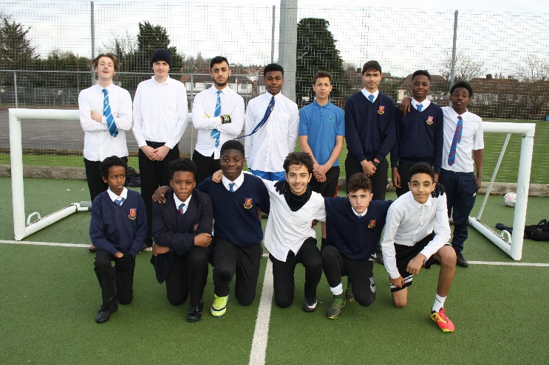
West Ham team photo - Players from Yr7, Yr8, Yr9 Yr10 & Yr11

