Student Guide to Google Classroom

Preston Manor School

This guide should help you with any problems you are experiencing with Google Classroom.
Please speak to your form tutor and to your class teacher if you have any other problems with using Google Classroom.
You can also use the remotelearning@preston-manor.com email address to ask questions or raise concerns.
How to Join and Use a Google Classroom

THIS IS A VERY HELPFUL VIDEO WHICH EXPLAINS HOW TO USE GOOGLE CLASSROOM STEP BY STEP: https://www.youtube.com/watch?v=lMOLD3CNZaU

- Sign in to Google using your school email address.
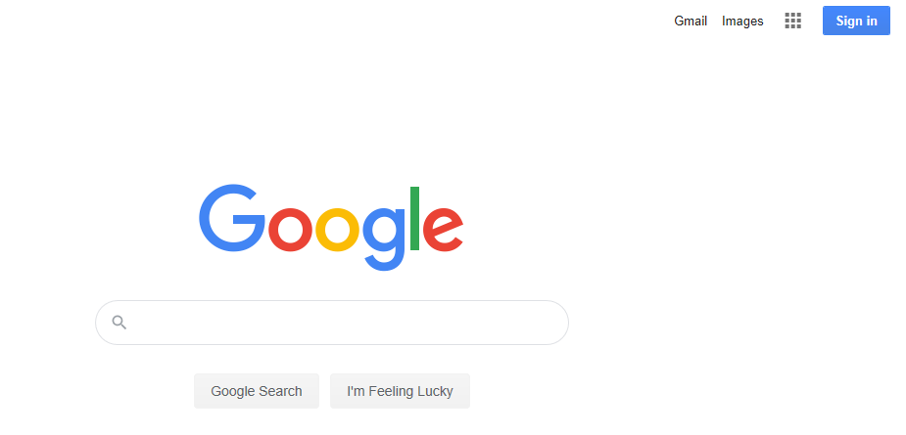

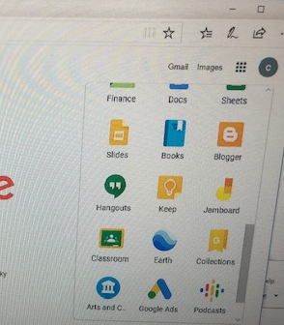
- Scroll down and click on Classroom.

- You will see the classes that have already been joined. If you have not got access to a classroom, then check that you have accepted the invite from your teacher in your school email. See below for more information on this.
In this area you can check which tasks need to be done under ‘To-do’. If you click on a class, you can see which resources are available.
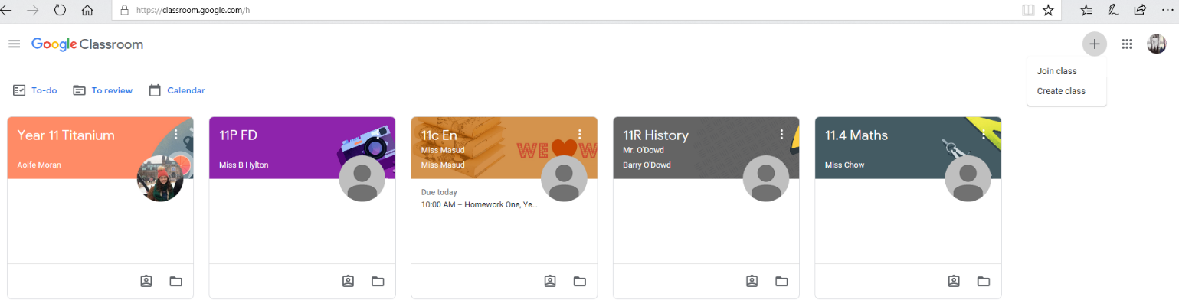

- Under the ‘To-do’ section you can see which tasks have been set, are missing and have been done.
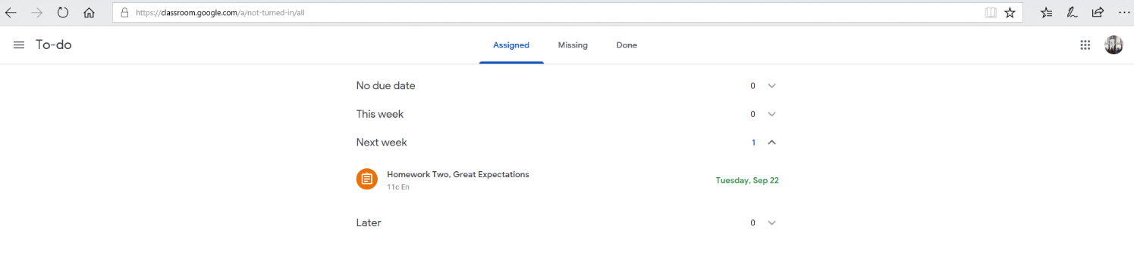

- When you click on the task, you will see a description of the work that needs to be done and any resources that the teacher has uploaded.
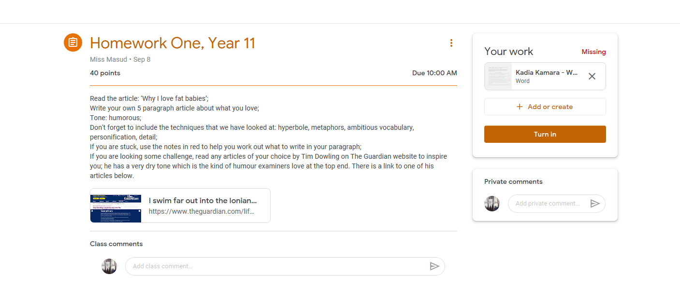

- Students can complete the task in a number of ways: a) opening a new document and typing their answer, b) typing straight into Google Docs or c) by hand-writing their answer and uploading a picture of it.
- Open a new document by pressing ‘Add or create’ and submit it by pressing ‘turn in’.
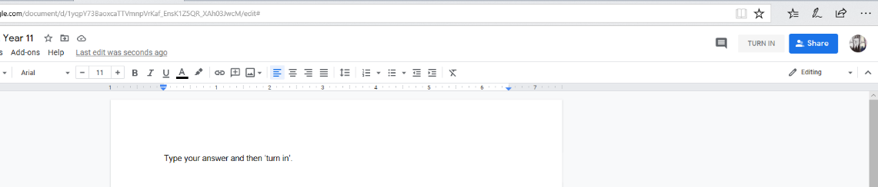
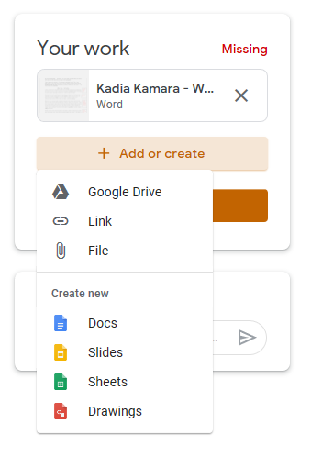

- If you have typed straight into Google Docs, it will save automatically in your Google Drive. To submit it, go to ‘Add or create’ and click on ‘Google Drive’. The document will be under ‘Recent’ and ‘Today’; select and insert it and you can then submit it by pressing ‘Hand in’.
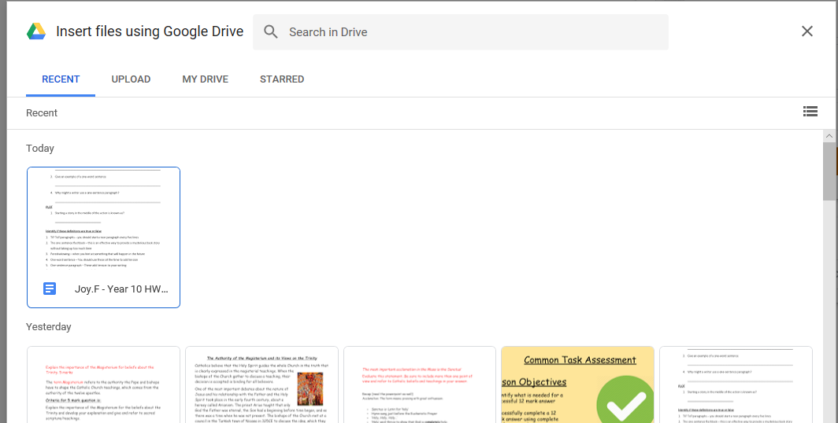

Joining a Google Classroom Using a Class Code

In most cases, your teacher will send you an email invite to the Google classroom. However, they can also tell you the class code. After you get the code, follow these steps:
- Go to classroom.google.com.
- Make sure to sign in with the correct account. If you're already signed in and need to switch accounts, in the top-right corner, click your profile picture and then select or add your account.
- At the top, click Join class.
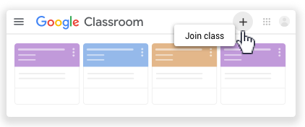
- Enter the class code from your teacher and click Join.
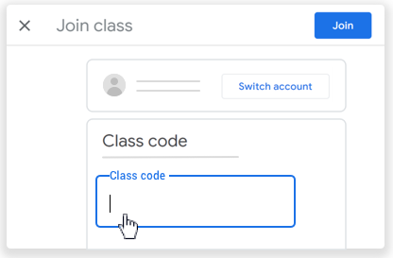
Note: Class codes are 6-7 characters, and use letters and numbers. Codes can’t have spaces or special symbols.

How to Fix Common Problems

- Cannot access Google classrooms

If you cannot access a Google classroom for a subject, please check that you have accepted every email invite for Google classrooms in your school email inbox. After you accept the classroom invite, you will be enrolled in that class for all your devices. You may need to log into your Google classroom using your school network / school email sign-in.

If you cannot find your Google classroom invite anywhere in your email, please email your subject teacher directly as they will be able to add you to your Google classroom and resend the invite if there has been a problem. If you have been added to the wrong Google classroom for a subject, you should email your subject teacher directly to ask to be added to the correct classroom.

You must also check that you are logging into Google classroom using your school email and not your personal Gmail account. You will need to log out of your personal Gmail account to ensure that Google Classrooms does not try to open any documents using the incorrect account.

- Cannot open files / access audio and video recordings in Google classroom

You must first check that you are logging into Google classroom using your school email and not your personal Gmail account. You will need to log out of your personal Gmail account to ensure that Google Classrooms does not try to open any documents using the incorrect account.

If you are finding it difficult to open files on Google classroom, you may need to download the files to your computer to be able to open them fully. This may also apply to audio and video files which are included within Powerpoint / Google Slides presentations (e.g. where a teacher has added a voice recording on a Powerpoint slide) as the presentation may need to be downloaded to allow you to hear / view the audio and video elements.

If you are finding it difficult to watch video recordings on the Google classroom, you should also check that the sound is not muted and that you are not running lots of additional programmes which could result in the video or audio streaming very slowly.

- Cannot submit work in Google classroom

You should look for your work to complete in the ‘Assignments’ section of your Google classroom for each subject. You should submit your work by uploading files that they have been working on. This webpage gives detailed advice about how to do this: https://support.google.com/edu/classroom/answer/6020285?co=GENIE.Platform%3DDesktop&hl=en
This YouTube video also shows how to upload a photograph of your work or a Google document to the Google classroom: https://www.youtube.com/watch?v=f_eQbtFRhNw

In some cases, your teacher will provide a document on Google classroom which they want you to complete as a task. If this is the case, you will usually have your own named copy of the task and can complete the activities in the files and immediately click ‘submit’ when the tasks are complete. If you do not have your own named copy of a task, you should download and save your own copy of the document to complete your work, otherwise you may end up submitting a blank document. Once you have completed your work you should then upload the document to the Google classroom.

If you are totally unable to submit your work through the Google classroom, you should email your work directly to your teacher using your Preston Manor School email address.

- Cannot access Zoom / Google Meet teaching

It is important that you join the Zoom or Google Meet session using their full name. You will only be admitted from the waiting room if your teacher recognises your name and can verify who you are. You should also join the session promptly, as once teachers begin their lesson it will be more difficult for them to admit students from the waiting room.

If you are still struggling to join a Zoom or Google Meet teaching session, you should check the following settings on your computer:
- Do your permission settings allow Zoom or Google Meet to access your webcam and microphone?
- Is your Wifi or internet signal strong enough to maintain an internet connection during a video call? If this is a persistent problem, please contact the school as we may be able to support with accessing a 4G dongle for you

If you are still unable to join a Zoom or Google Meet teaching session, you will also be able to access the recording of the session on their Google classroom after the lesson and can watch this in your own time.

