Preston Manor School GCSE Press Release 2021

There was celebration and excitement at Preston Manor School today as students received their GCSE results. Examination results across the entire school gave the opportunity to celebrate after recent times and students and staff celebrated a long list of individual success stories. With the cancellation of exams, grades were awarded through a rigorous process of teacher assessed grades that were checked by the awarding exam boards to ensure accuracy and consistency.

There were a number of students who received the top grades of 8/9 across all their subjects, which they put down to dedication to their studies and the support of staff. Iona Fernandes (picture 1) (who achieved seven Grade 9’s and three Grade 8’s) came in early to collect her results and said, “I’m so thrilled with the grades I’ve achieved.” Jay Cangi (11 Grade 9-7’s including five 9’s, five 8’s and one 7) said “I’m really happy with my results. I want to thank all the teachers who helped me achieve my grades. I’m excited that I’m going to be staying in the Preston Manor 6th Form and continuing my education here.”

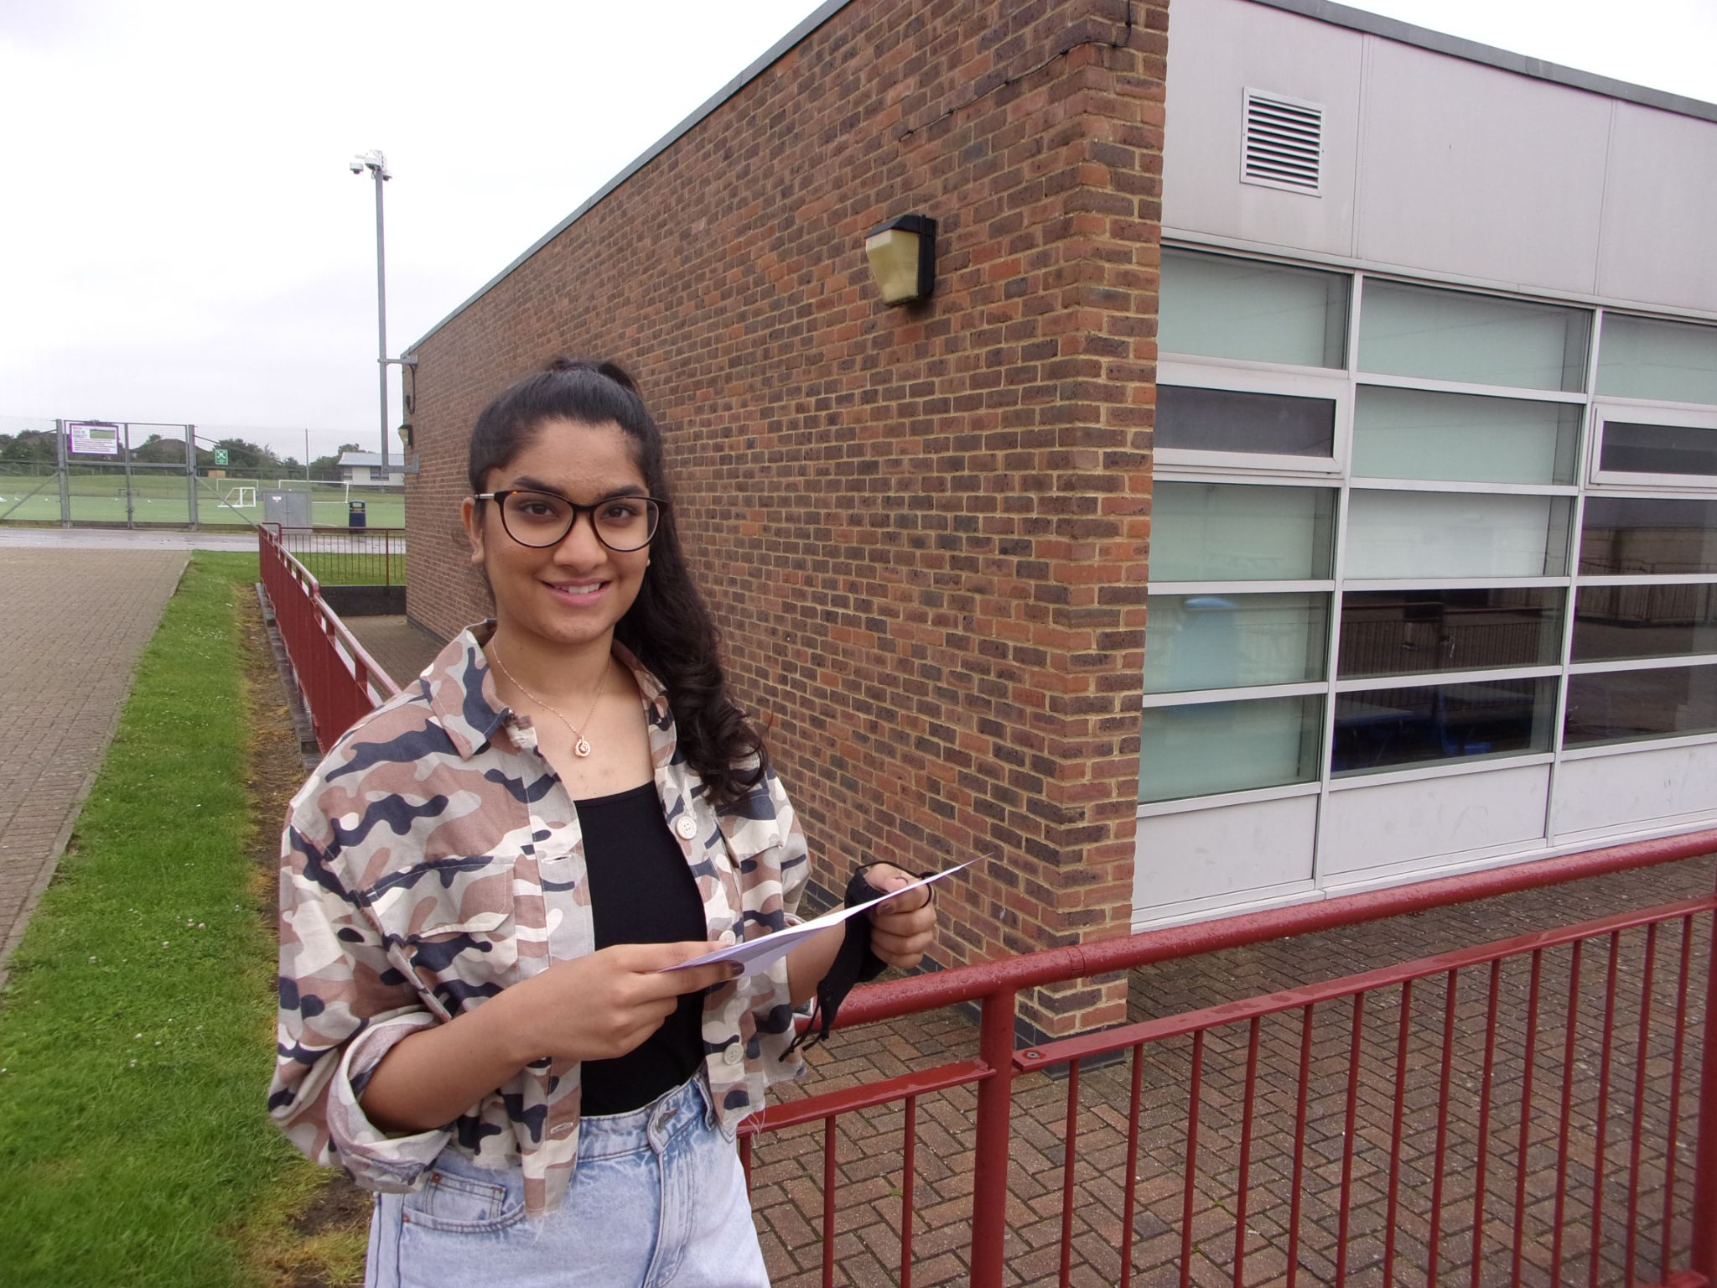
Picture 1 - Iona Fernandes

The headteacher, Beth Kobel, was delighted: “I am so proud of our students here at Preston Manor. They have worked incredibly hard and have achieved so very much throughout their time at school, well beyond what our traditional exams measure. However, today is about celebrating their results and I am really pleased for them. Our students have shown resilience and determination throughout an incredibly challenging time. We are all very proud of what they have achieved and I know they will be successful in their next steps.”

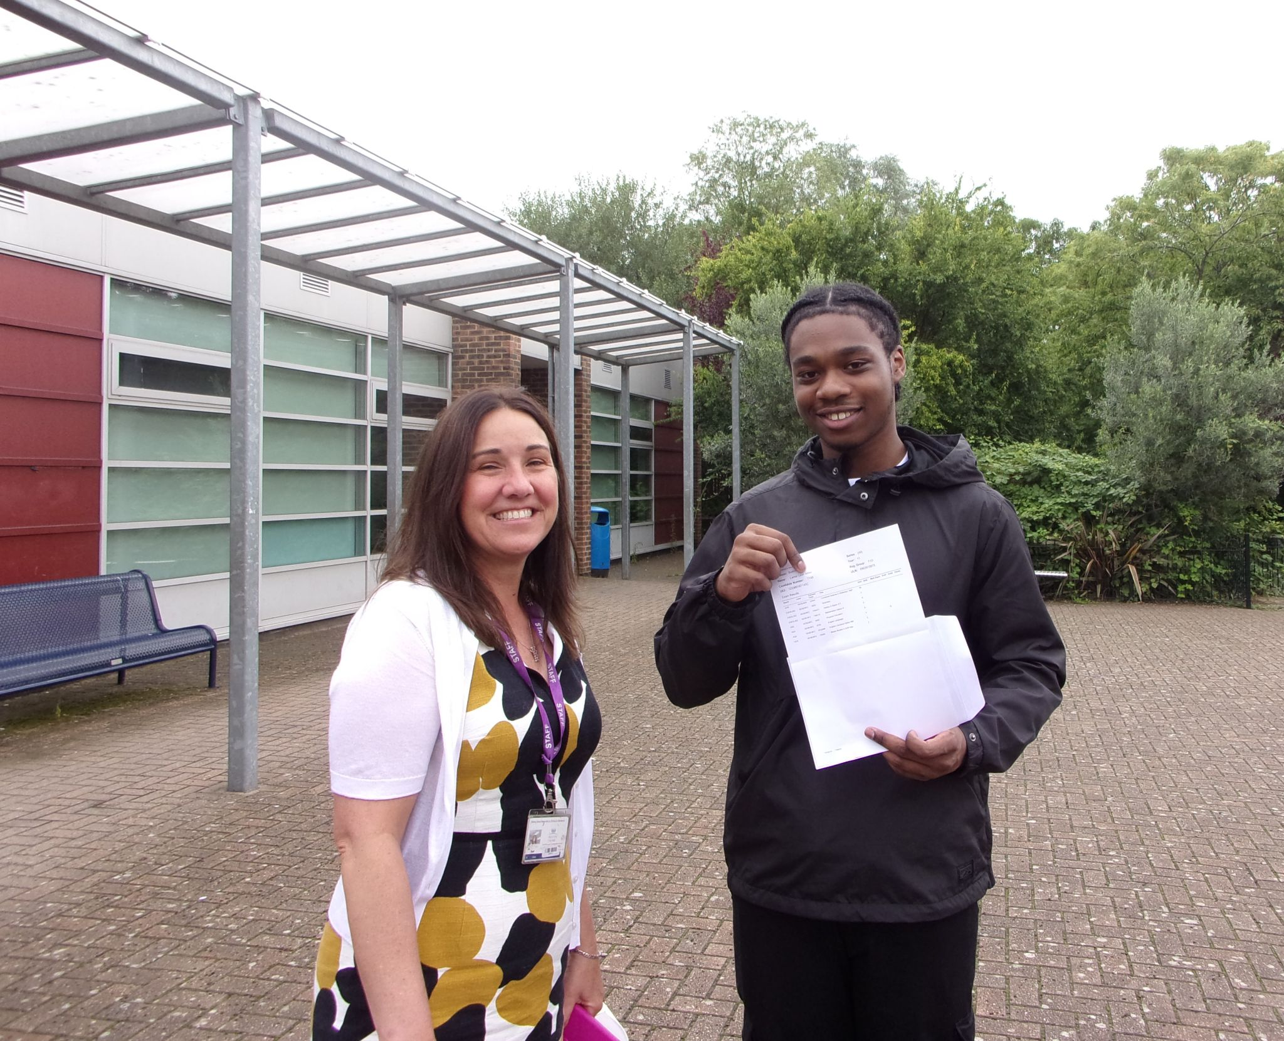
Picture 2 - Beth Kobel & Lamar Miller

Ms Kobel is pictured (picture 2) here with Lamar Miller, who achieved fantastic results and exceeded his targeted grades in a number of subjects. He said, “I want everyone to know that if you put in hard work and passion then big rewards will come. I want to thank the teachers for being role models, pushing me and making me excel. Thank you to my Mum for raising me so well too!”

Another student who received consistently high grades, Sharley Patel (11 Grade 9-7’s including five 9’s, four 8’s, and two 7’s), spoke excitedly about her results, “I’m really happy and this shows that hard work pays off.”

Alex Prodan (below) who achieved 11 Grade 9-7’s (including five 9’s, five 8’s, and one 7): “I’m really happy and excited to be coming back to Preston Manor Sixth Form in September.” Fellow student Raneem Safieddine (achieving four Grade 9’s and six Grade 8’s) said, "If you believe in yourself and work hard you can achieve anything."

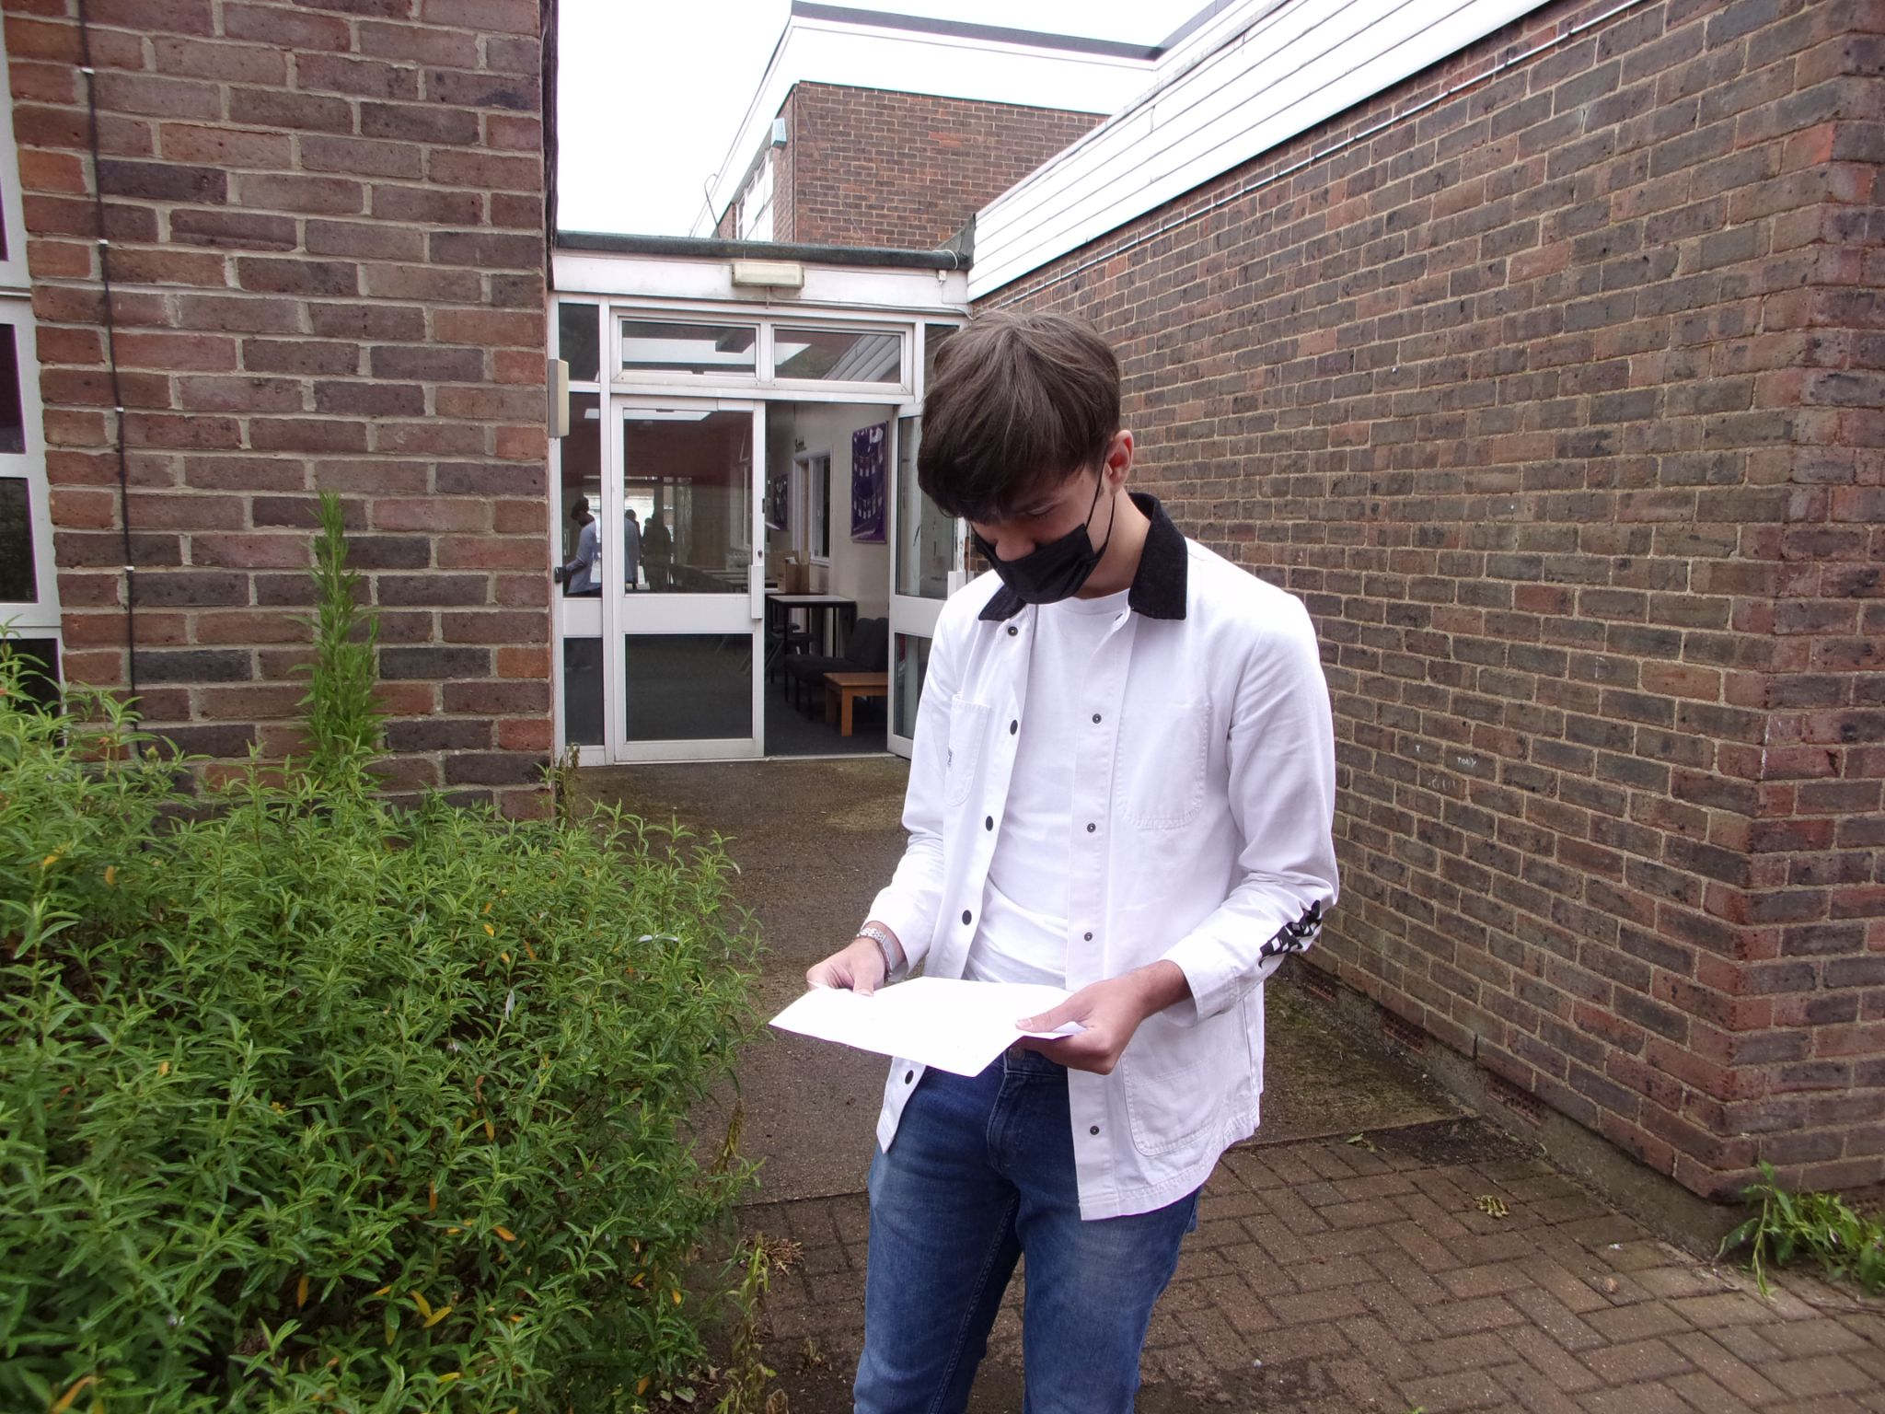
Picture 3 - Alex Prodan

Celebrating below are friends Thiviya Paskaran (six grade 8s, three grade 9s), Mazama Rustamkhil (seven grade 8s, three grade 9s).

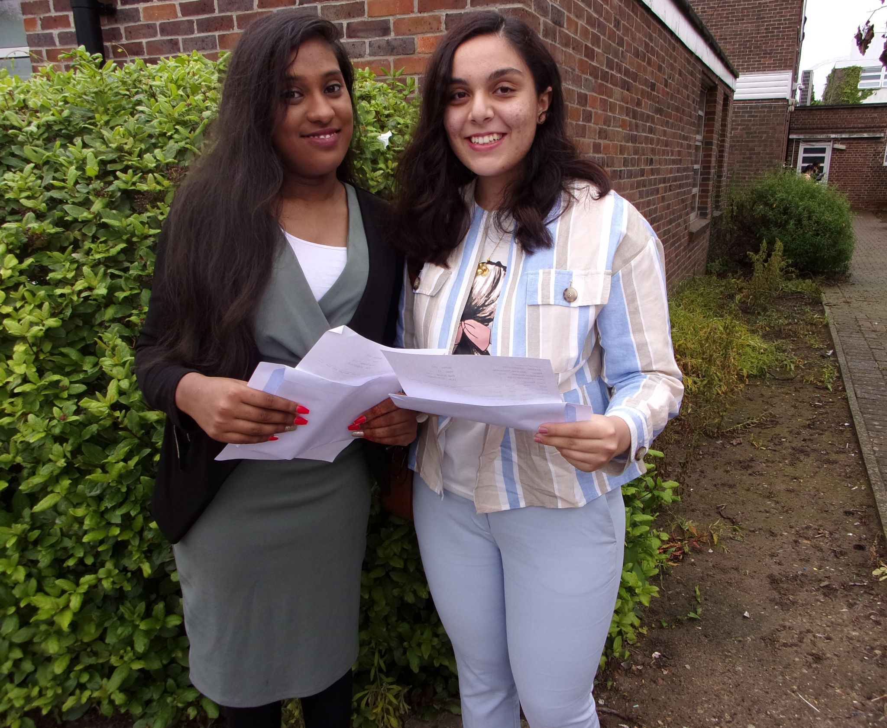
Picture 4 - Thiviya Paskaran & Mazama Rustamkhil

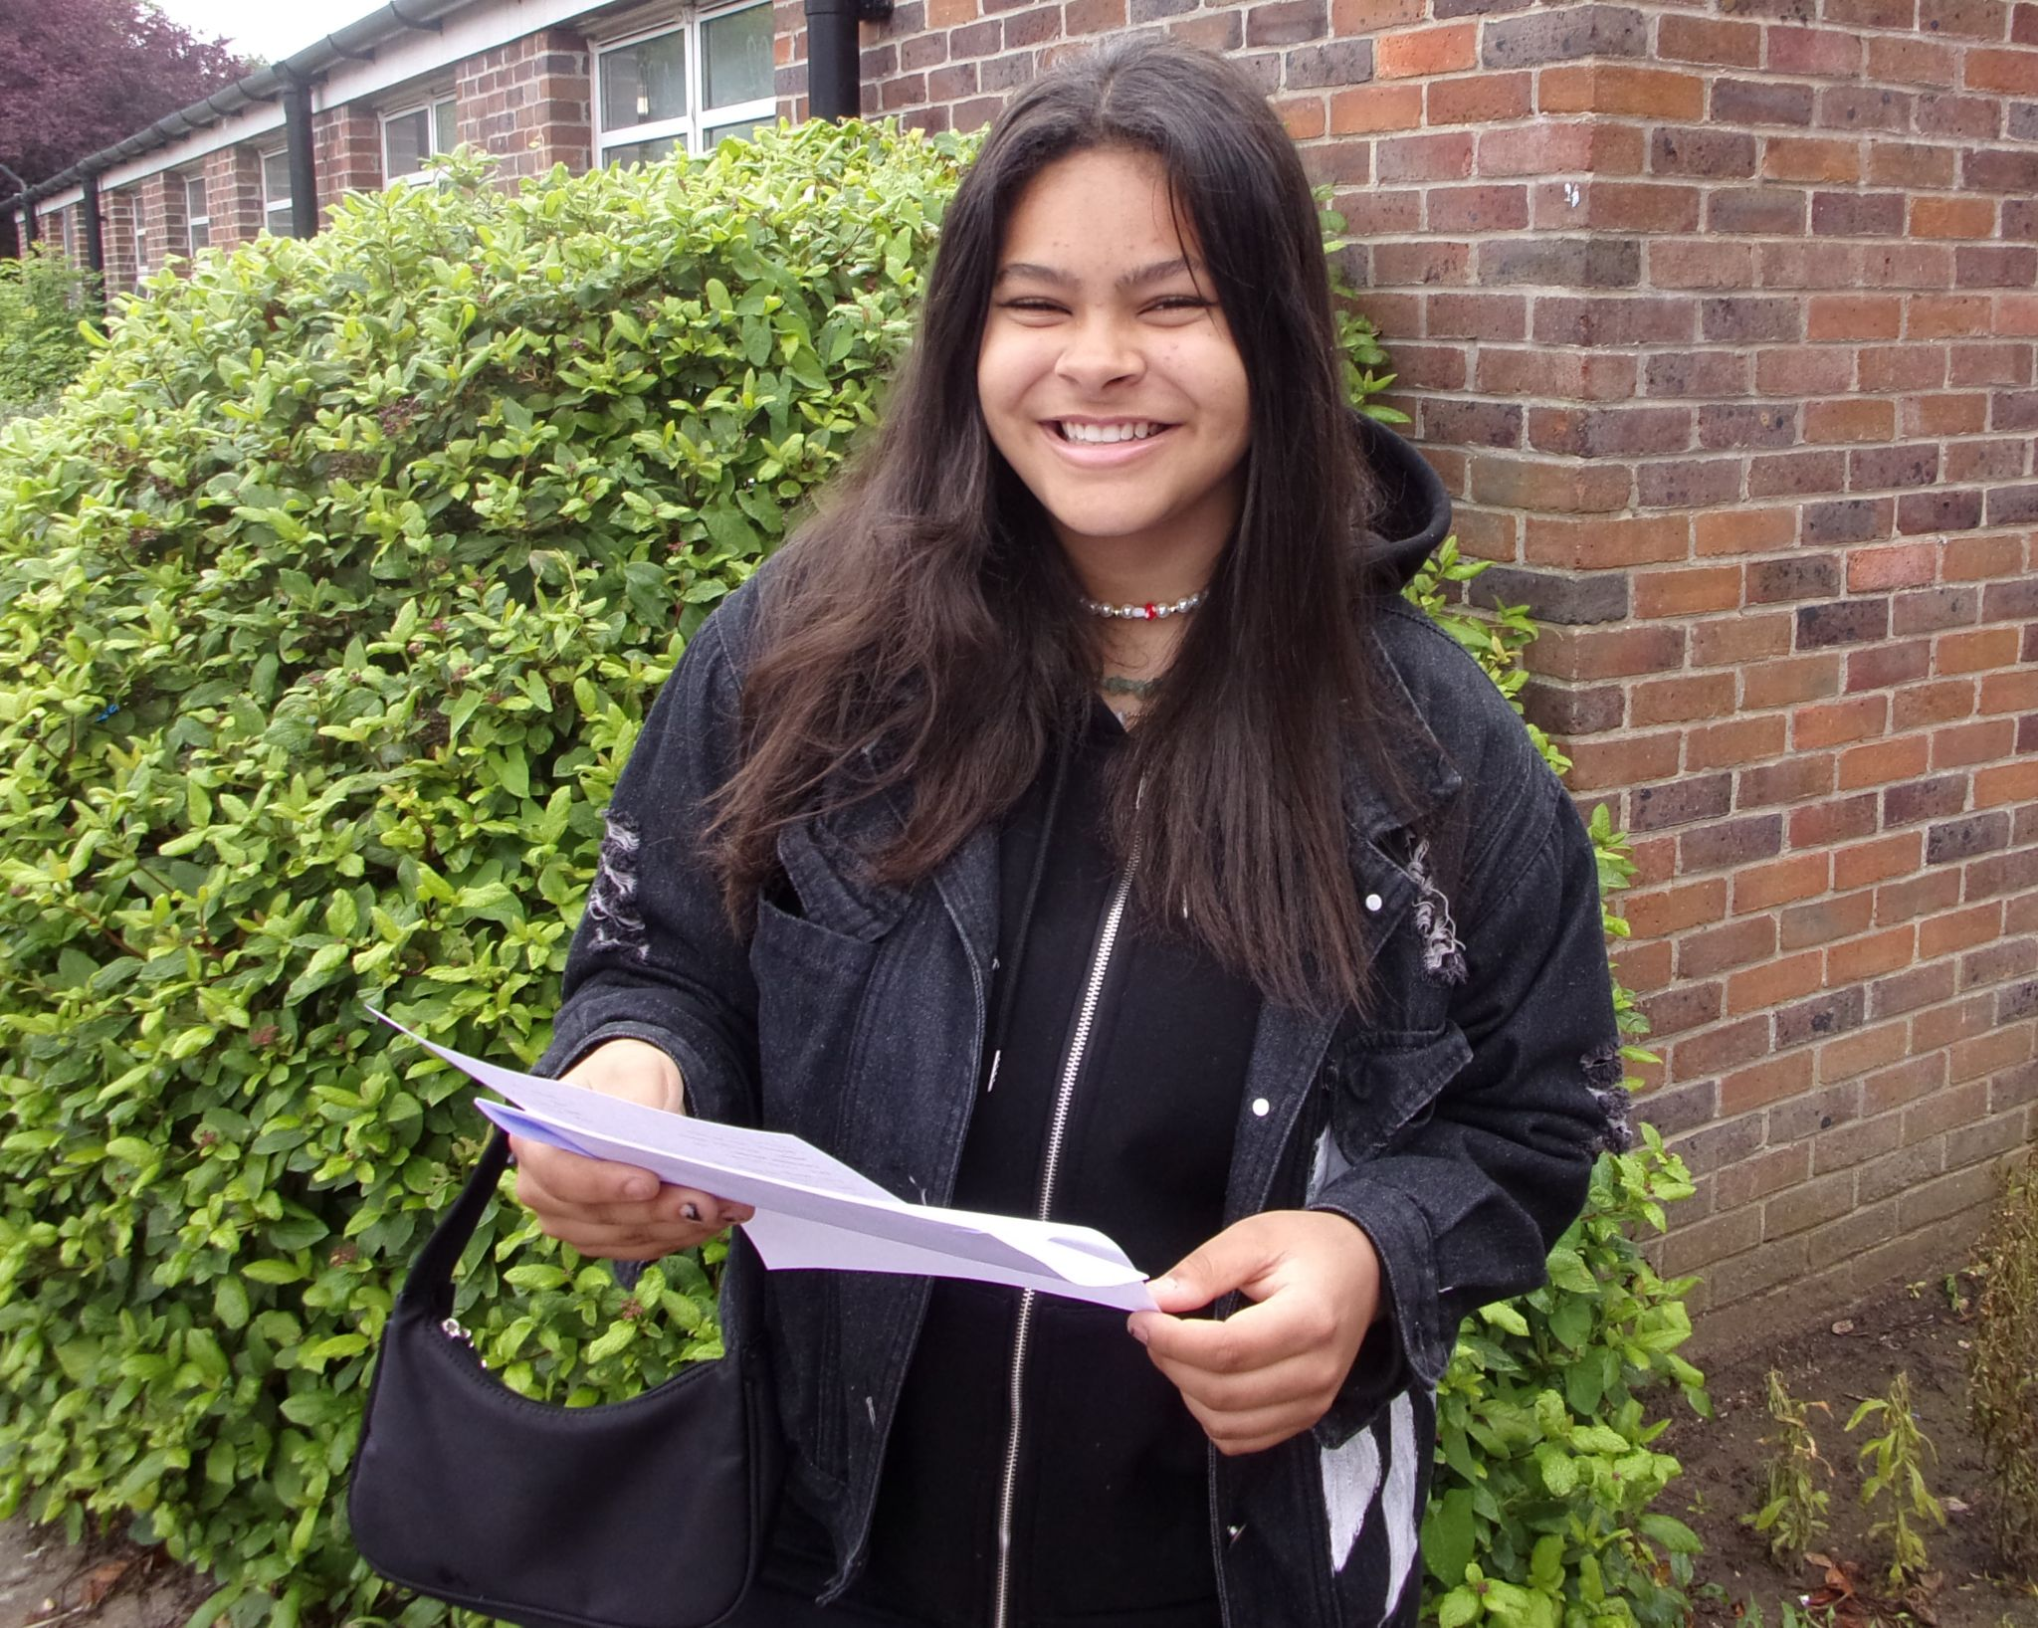
Picture 5 - A big smile for Anna Rabello (three grade 9s, three grade 8s, four grade 7s)

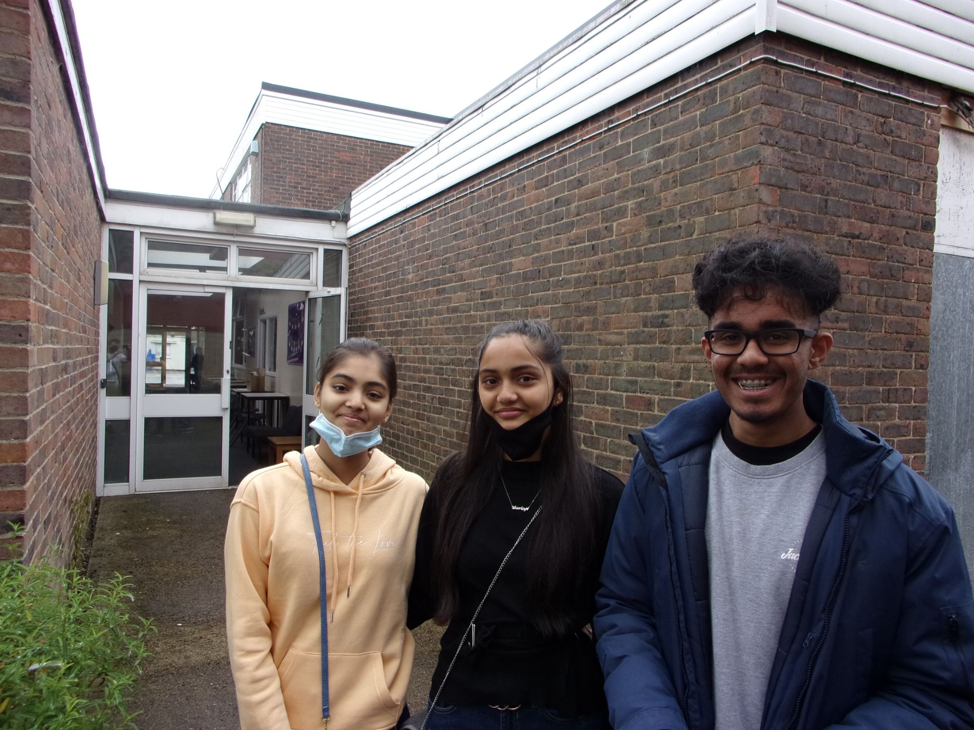
Picture 6 - Big congratulations to Manisha Patel (five grade 9s, four grade 7s), (five 9’s, four 8’s, and two 7’s) Hajanujan Vasantharaja (three grade 9s, two grade 8s, four grade 7s).

Preston Manor would like to congratulate all their students on their success and to wish them well for the future, whether at the school 6th form or in other post-16 routes.

