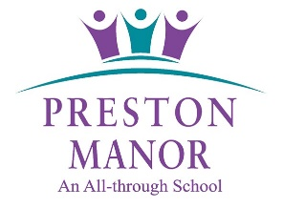

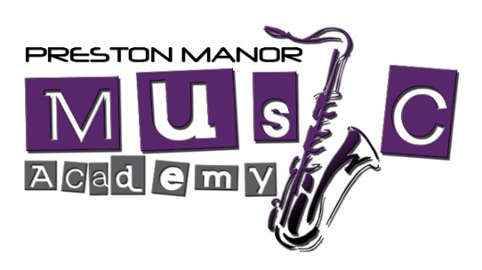

Preston Manor School, Carlton Avenue East, Wembley, Middlesex, HA9 8NA

Executive Head: Mr R. Denial Director of Music: Mr. K. C. Crawley GTCL, MMUS
Music Department Direct Line Telephone: 020 8385 4068

The Preston Manor Music Academy is a small independent quintuple award winning Saturday community music school for 6 to 18 year olds that offers a choice of instrumental lessons but also the chance to play in an orchestra or ensemble sing in a choir and study music theory. We currently offer small group lessons in piano, keyboard, flute, violin, classical, electric and bass guitar, ukulele and drum kit. Pupils attending Preston Manor’s Upper or Lower School receive first priority.


There are two membership categories:

Membership Category | Description and Age Range
Music Academy | Open to high school aged students from Year 7 to 13 from both Preston Manor School and the surrounding community
Junior Music Academy | Open to primary school aged students from Year 2 to 6 from both Preston Manor’s Lower School and the surrounding community.

Studying music theory not only enables a student to achieve a greater understanding of the music they are learning in their instrumental lessons but also allows them to pursue the Associated Board/London College/Rock School exam system up to and beyond grade five. The theory of music is not offered as part of the National Curriculum but extra-curricular study can help any child in their appreciation and understanding of classroom based music lessons. In addition, the QCA recognises that the study of both practical and theoretical music to a grade five standard is equivalent in points to a GCSE. Achieving above grade six can also earn pupils UCAS points that count towards meeting offers made by universities.

At first, instrumental lessons are taken in small groups; pupils studying for GCSE Music at Preston Manor may have their lessons in pairs or individually, subject to the Director of the Music’s approval. Whilst learners are encouraged to take graded exams; we have had a number of recent exam successes (including students passing Grades 6 to 8) in both practical and theoretical exams for a range of exam boards, this is by no means compulsory. We are also able to prepare Year 5 or 6 students for the Grammar School Music Aptitude Test.

The Music Academy holds Roland’s Champion School for Music status, has won a Mayor of London’s Excellence in Music Schools award, and has achieved ABRSM’s Music Mark status for five successive years.



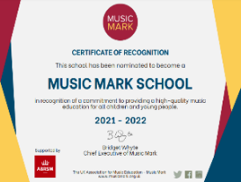

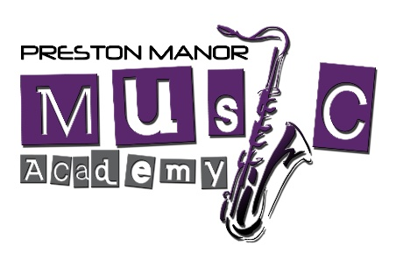

Music Academy Application Form
Please complete in neat, clear block capitals

The Cost:

Please see the pricing sheet on our website for this year’s academic fees. Currently we are operating in five week half termly blocks with the relevant fee paid by the end of each block.

PUPIL’S NAME:

PUPIL’S FORM / CLASS if attending Preston Manor School:

PUPIL’S AGE and SCHOOL YEAR:

Instrument Choice – please tick the relevant box or boxes below:

Piano |  |  | Electric Guitar  (Limited Spaces)
Keyboard |  |  | Classical Guitar  (Limited Spaces)
Ukulele  (Limited Spaces) |  |  | Bass Guitar  (Limited Spaces)
Drum Kit  (Limited Spaces) |  |  | Violin

Musical Experience:
(No previous musical experience is necessary)

Address including postcode:

Parent/Guardian Email Address:

Parent/Guardian Telephone Numbers:

Parent/Guardian Signature:

