Premier League Enterprise Challenge Regional Finals 2019:
The Results!

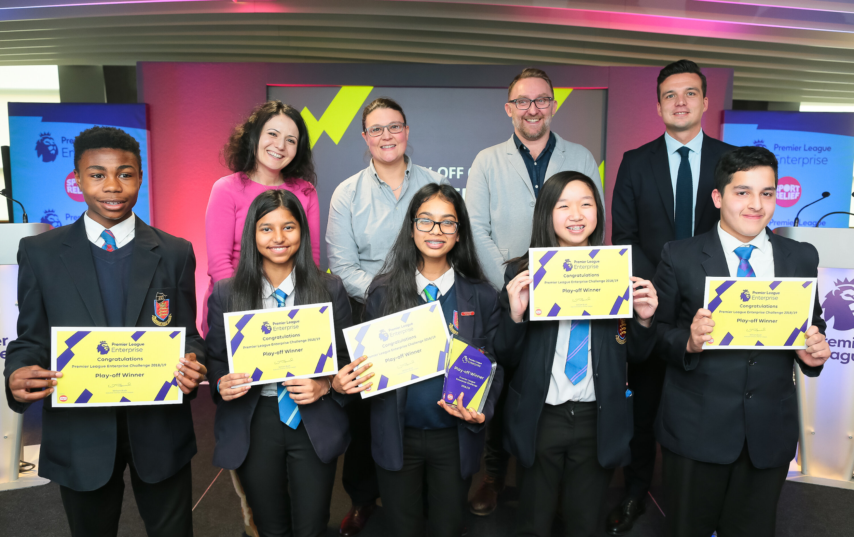

Five students from Year 10 made the trip to The American Express Community Stadium on 30th January 2019 after being selected to represent QPR FC at the Premier League Enterprise Challenge Regional Finals 2018-19.

Now in its tenth year, the Premier League Enterprise Challenge is delivered in partnership with Sport Relief. The programme aims to inspire young people to engage positively in education and raise awareness of the world of work, through the power of Premier League football clubs.

Preston Manor School students have been working with QPR in the Community Trust for the past six weeks to develop their Business plan of engaging young adult supporters aged 18-23 years old. They also had to ensure their preparations covered other key areas of the programme set by The Premier League.

After much deliberation, the Judges returned to announce Preston Manor School as Premier League Enterprise Challenge Play-off 6 Regional Finals Winners.

Preston Manor School will now represent QPR FC at the Premier League Enterprise Challenge National Finals to be held at the prestigious Ernst & Young office in Central London on the 18th of March 2019.



