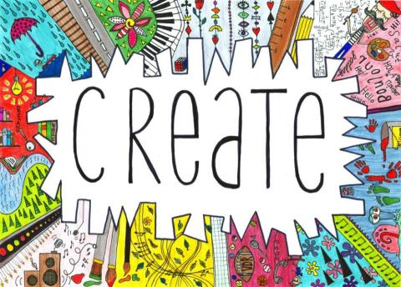
In the boxes below are a range of activities and resources that we hope will inspire you and encourage you to try something new.

You can experience everything from museums and galleries to theatre or learning some yoga skills. We would love to hear about what you tried out when you return to school.

Natural History Museum - there are some great online resources and tours here.  Why not look through the images from the Wildlife Photographer of the Year competition (some of them are amazing - check out the marmot and the fox(!) and the tarantula)... https://www.nhm.ac.uk/wpy/gallery  Or you can tour around the galleries and see lots of the exhibits here… https://www.nhm.ac.uk/visit/virtual-museum.html  Take some screenshots of your favourite exhibits from the museum and your favourite photos from the Wildlife Photographer exhibition.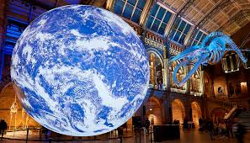 | Tate Gallery Tasks - try out some of these fun tasks from the Tate gallery…  Draw a sound creature: https://www.tate.org.uk/kids/make/art-technology/draw-sound-creature  Make some Pop Art like Andy Warhol: https://www.tate.org.uk/kids/make/paint-draw/make-pop-art-warhol  Or try another task: https://www.tate.org.uk/kids/make  You can take photos of your final pieces and upload them to your Summer School file. | Go on a virtual tour of the British Museum - https://artsandculture.google.com/streetview/british-museum/AwEp68JO4NECkQ?sv_lng=-0.1266024509257022&sv_lat=51.51905368906714&sv_h=326&sv_p=0&sv_pid=JeKwUFYAMWXNWPh3IOg3jw&sv_z=0.9999999999999997  As you travel round the museum, can you find…  - The amazing glass ceiling in the main hall (tilt the camera up!)  - A carved 12th century chess set from a Scottish island  - A stone sculpture of a ram - can you find the scarab beetle sculpture in the same room?  - Wooden sarcophagi from Egypt - and some actual mummies too.  - A big sculpture of the Buddha  Can you take screenshots or everything that you find and add them to your folder?
Yoga for schools - do you fancy teaching yourself some yoga? Try out some of these videos and see if you can work on your flexibility and relaxation.  https://www.youtube.com/channel/UCW56cm0SXozQzVH3GNn6t8A  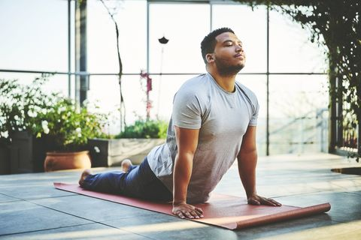  Take some photos of yourself in your best yoga poses as you try out the videos. | Online Theatre and Circus Shows - here are some online shows for you to watch.  A Globe production of Romeo & Juliet...  https://www.youtube.com/watch?v=wFBWXRqa7Gs  And an amazing show from Cirque du Soleil… https://www.youtube.com/watch?v=nQ5eUJNXrMw  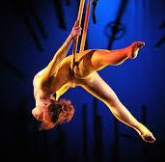  Can you write a review of your favourite one? Remember to include what you liked, what you thought could be improved and whether you would recommend it overall. | Success at School: Career Zone - you can use the sections of this website to find out information about skills and careers...  Use this link to explore different careers and sectors: https://successatschool.org/careerzones  Use this link to find out about employability skills: https://successatschool.org/advice/employability-skills  Can you research two careers that you might want to pursue in the future?  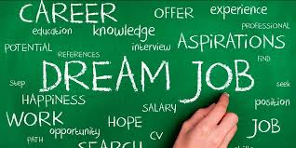
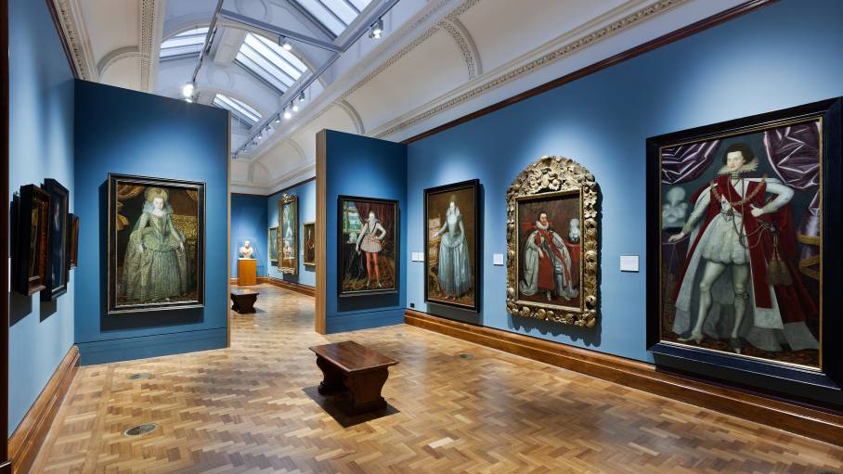  Look around the National Portrait Gallery - this is an amazing exhibition of some of the most famous portraits in the world...  https://www.npg.org.uk/visit/360-gallery-views/  Can you take screenshots of your 3 favourite portraits?  You might even be inspired to create your own portrait based on one of the ones that you see here. | Explore Audible - they have an amazing range of free audio books to listen to across the summer.  https://stories.audible.com/start-listen  Can you listen to at least two books of your choice and write a plot summary for each of them? | Watch a webcam from the Monterey Bay Aquarium in California - relax and watch some jellyfish, a coral reef or even some sea otters!  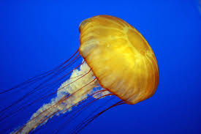  https://www.montereybayaquarium.org/animals/live-cams  Can you create a fact sheet about one of the sea creatures you can see?
Blue Peter Badges - This might be the summer to try and earn a Blue Peter badge. There are lots of different types and many different ways to earn them.  https://www.bbc.co.uk/cbbc/joinin/about-blue-peter-badges  Can you use this page to research a badge and try to apply for one? This is a big challenge so bonus points for anyone who can complete this! 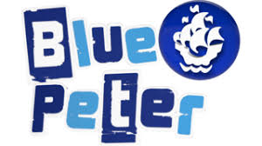 | Crash Course - a whole range of videos explaining lots of different topics. You can get a crash course in almost anything here!  https://thecrashcourse.com/  Can you watch at least 5 different videos and summarise the content of each one in 3 sentences?  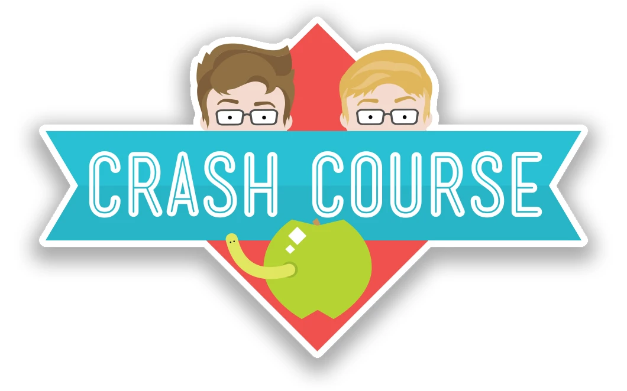 | National Theatre - here are some fun activities - including a backstage tour - that you can try at home…  https://www.nationaltheatre.org.uk/sites/default/files/lets_play_at_home_final.pdf  Can you complete at least 4 different activities from this sheet?

Good luck with the tasks! We hope you really enjoy completing them.

